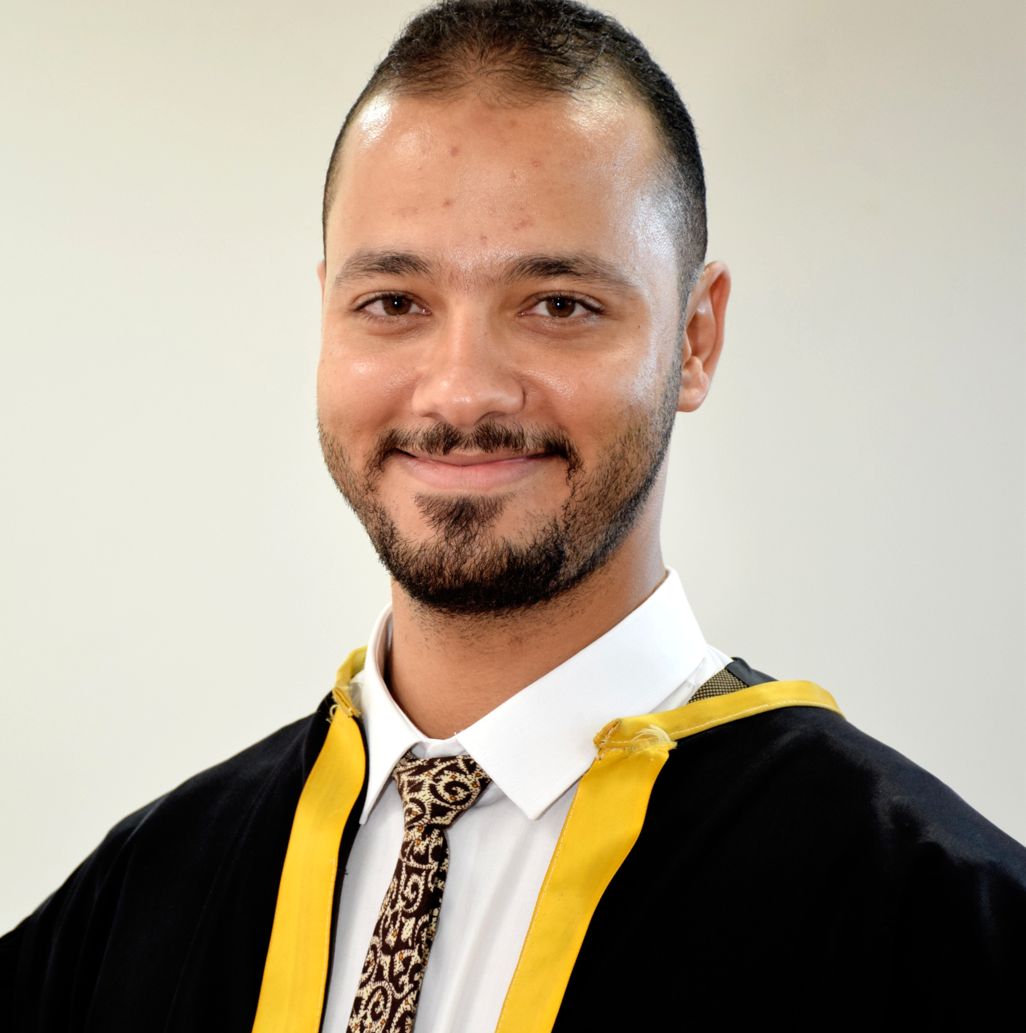 |  | Ahmed  abdelmoeen  Associate professor at faculty of Physical Education, Benha University
Contact  PHONE:  +201012089879  WEBSITE:  https://www.researchgate.net/profile/Ahmed-Abass  https://www.bu.edu.eg/staff/ahmed.abdelmoaen  https://www.linkedin.com/in/ahmed-abdelmoeen-a86aa310b/  https://orcid.org/0000-0003-0111-4598  EMAIL:  ahmed.abdelmoeen@fped.bu.edu.eg  dr.dodybusiness2020@gmail.com  Hobbies  Travelling  Reading  Working out  Getting to know people of a different culture. |  | EDUCATION  PhD. 2020  Designing a Technological Medium to Enhance the kinematical Variables of Certain Racket-Sports Skills  Mstsc. 2016  Setting up a battery test to measure the coordination ability for tennis junior  WORK EXPERIENCE  Benha university - Associate Professor  2021– Now  Senior lecturer At Physical Education college at Benha uni.  Benha University – Coach of teams  2017– Now  Coach of Benha University Table Tennis team till 2020 and Tennis team 2021- now  Fitness Trainer  2015 – Now  Working as a Fitness Trainer at many clubs in tennis team and now having my own academy (FIT AND FEAT FITNESS ACADEMY).  International Academy of Sports Science and Technology (IASST) instructor  2022 – Now  Lecturer at (IASST) in CPT, CFT and CSCS courses  SKILLS

